Setup a Spark Cluster Step by Step

In this exercise, you will learn how to set up a Spark cluster with 3 machines.

A few links for your reference:

Set up a local Spark cluster step by step in 10 minutes | by Andrew Zhu | CodeX | Medium

Install Apache Spark on Multi-Node Cluster - DataFlair (data-flair.training)

Spark Standalone Mode - Spark 3.2.0 Documentation (apache.org)

Suppose there are 3 students in your group, each student has created an instance on Tencent cloud. Let’s suppose the instances are named as: X1, X2, X3.

Step1-5

If your group has done setup a Hadoop cluster step by step, you should skip step 1-5 and do step6-11.
We suggest you use hadoop name node as master node for Spark cluster.

Step 1:
Select one instance as master node for Spark cluster, for example X1 is selected as master node, the remaining instances are used as worker nodes (X2, X3)

Step 2:
In order to create a cluster with three nodes/instances, you need to set Security Group to all.

Connect to cloud.uic.edu.cn, and select one of the nodes, click Network Operation menu, you will see the following menu:

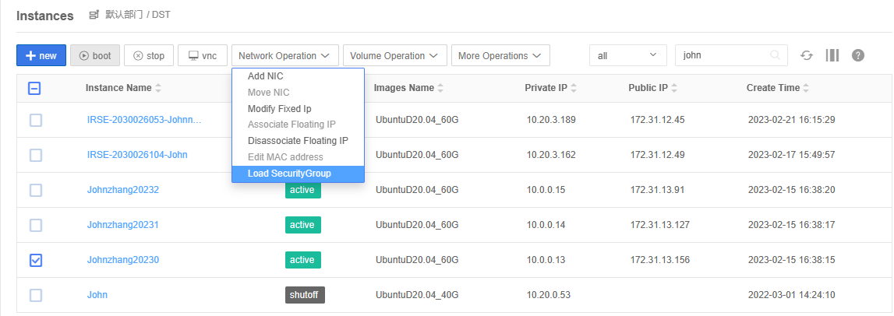
Click Load SecurityGroup, the following window will pop up:
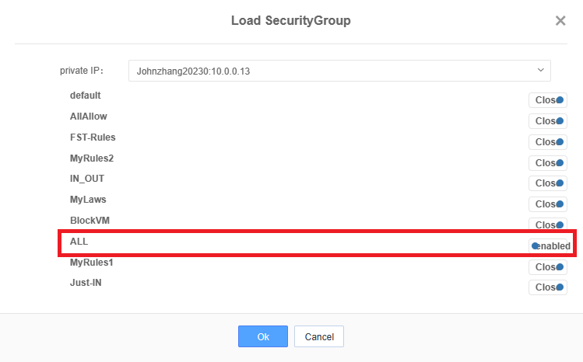

Select All and enable it, and click Ok button.

Repeat the above operation for each node.

Once you have finished this setting, you can ping each node to make sure they are set correctly.

Step 3:
Set non-password login between nodes

- Generate the public key of SSH on X1
# ssh-keygen –t rsa –P ‘ ’ –f ~/.ssh/id_rsa

Make sure you already edited hosts for each node
(refer to lab5 Setup a Hadoop Cluster, step 2)

- Copy and send files to X2, and X3
# ssh-copy-id X2

# ssh-copy-id X3

Do not forget to connect the master self
# ssh-copy-id localhost

- do the same operations above on the other two nodes.

On X2:
# ssh-keygen –t rsa –P ‘’ –f ~/.ssh/id_rsa
# ssh-copy-id X1
# ssh-copy-id X3

On X3:
# ssh-keygen –t rsa –P ‘’ –f ~/.ssh/id_rsa
# ssh-copy-id X1
# ssh-copy-id X2

- Test the ssh connection from master to work nodes.
On master: (X1)
# ssh X2
# ssh X3

Step 4:

Install JDK 8

- Do update and upgrade
# apt update && apt upgrade -y

# sudo apt install openjdk-8-jdk

Add the following environment variables into the file ~/.bashrc

export JAVA_HOME=/usr/lib/jvm/java-8-openjdk-amd64/
export PATH=$PATH:$JAVA_HOME/bin
if you already have these lines, skip this step.
Put the environment variables into effect immediately
# source /etc/profile
Or
# source ~/.bashrc

Verify java is installed correctly
# java -version

Step 5:
(both on Master and Workers instances)

the “/etc/hosts” file with your hostnames of your Spark Cluster:
[If you did lab5, you can skip this step (lab5 step 2: Install Hosts)]

On master node X1 and worker nodes X2 and X3, edit /etc/hosts file, and add the following IP and node names info:
(Suppose X1, X2, X3 IP addresses are 10.0.0.13, 10.0.0,14, 10.0.0,15, respectively)

Make sure use private IP addresses here!

10.0.0.13 X1 #Spark Master
10.0.0.14 X2 #Spark Worker1
10.0.0.15 X3 #Spark Worker2

Step 6:
Install Python 3.x on each node
(Each person do this step independently.)

# apt install python3-pip
# pip install pyspark==3.5.1 -i https://pypi.tuna.tsinghua.edu.cn/simple

Step 7:
Install Spark 3.5.1 on each node
(Each person do this step independently.)

# cd ~
# wget https://mirrors.bfsu.edu.cn/apache/spark/spark-3.5.1/spark-3.5.1-bin-hadoop3.tgz
# tar xfz spark-3.5.1-bin-hadoop3.tgz

Rename spark-3.5.1-bin-hadoop3 directory to spark
# mv spark-3.5.1-bin-hadoop3 spark

In step 6 & 7, we ask you to use 3.5.1 version. You should remember that new version will be released every year. Please try the latest version if available.

Step 8:
Settings and Configurations
(only Master node needs to do this step, not two workers)

Edit the “~/spark/conf/spark-env.sh” file of your Spark Master, add the following lines (replace with your own hostname and IP):

You don’t have spark-env.sh in your spark, it has spark-env.sh.template instead. You can rename it as spark-env.sh, and add the following lines at the end:

export SPARK_MASTER_HOST=”X1”
export SPARK_LOCAL_IP=”10.0.0.13”

(replace x1 by your master machine name, and replace 10.0.0.13 with your master node private IP address)

Step 9:
Set up environment variables for spark
(Each person do this step independently.)

# sudo vi ~/.bashrc
Add the following at the end:
export SPARK_HOME=~/spark/
export PATH=$PATH:$SPARK_HOME/sbin:$SPARK_HOME/bin
save it and run source:
# source ~/.bashrc
On master node
On worker 1
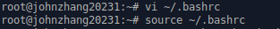
On worker 2

Step 10:
Run Spark Master and Worker nodes

First, on master machine, start the master node by typing:

# start-master.sh

you can use jps command to check the master running status
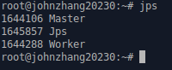

On each worker node, start each worker node by typing:
# start-worker.sh X1:7077

Here, X1 is your spark cluster master node machine name.

you can use jps to check worker running status
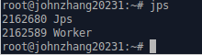
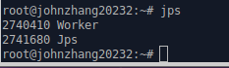

Step 11:
Run a spark python sample program pi.py
On your master machine, type the following command to start a python program:
# cd ~/spark
# spark-submit --master spark://X1:7077 examples/src/main/python/pi.py
(Here, X1 is your master node machine name)
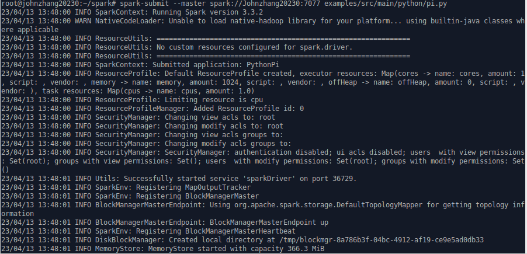
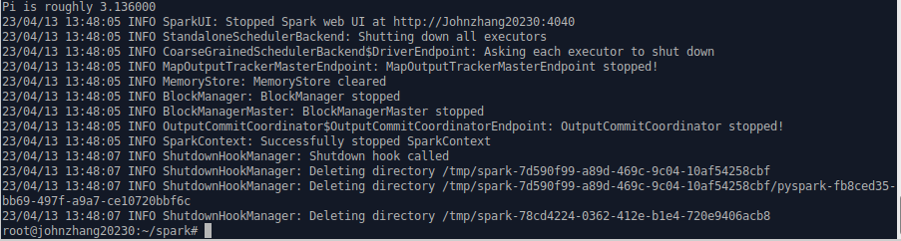
On your master machine, open a web page, type url: http://X1:8080, you will get something like:
(Here, the master node name is johnzhang20230. You should use your master node name)
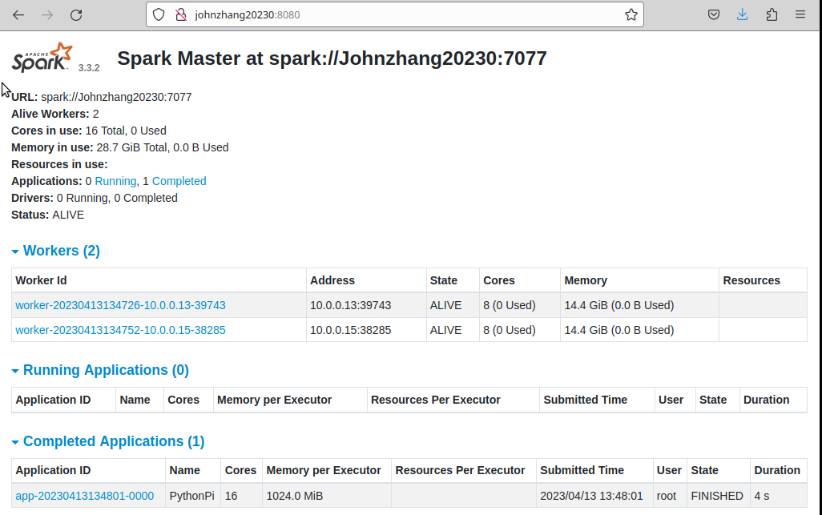
You will find your program is completed in Completed Applications section.
Congratulations! You have finally made it.
Step 12:
Stop the spark master and workers
On your master machine, type the command
# stop-master.sh

On your worker machines, type the command
# stop-worker.sh

